What to fix/debugg in mmwave_run.py (simply clean up code to get better data for integration)
-timestamp at each frame (change to timestamp to radars timestamp)
-confidence scale
-look into making data better (and output) for last known center when tracking a “person”

Debug checklist:
- output hygiene
  - STDOUT = NDJSON only ✔
  - STDERR = debug only ✔
  - One JSON object per frame ✔
- State correctness
  - reset ‘person’ every frame
  - center=null when num_points==0
  - No stale data reuse
- Contract clarity
  - Document timestamp units
  - Document coordinate frame
  - Document confidence meaning

Output:
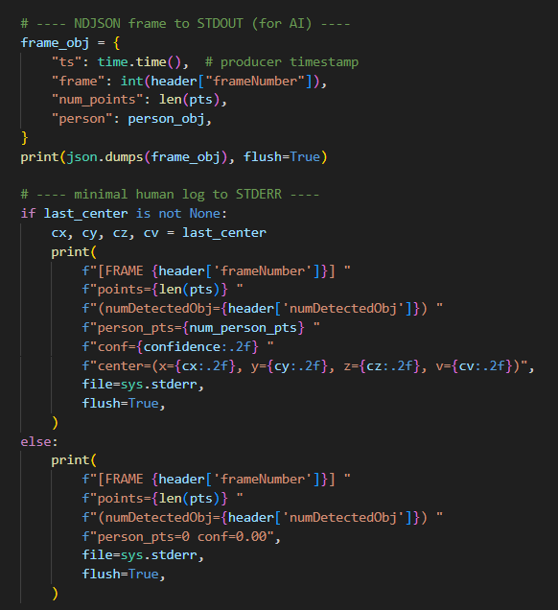
To explain the output, there are two different outputs that are going to the terminal. The first ‘line’ going to the terminal is the NDJSON frame, this is where you will see this:
The ML will be able to read the data (from left to right), the timestamp, the frame number, number of points, the confidence interval, and if there is someone being tracked, will also see x,y,z positioning and velocity.

The second output, ‘human log to STDERR,’ will be the second ‘line’ in the terminal following the NDJSON frame, where it’ll look like this:
This output is already coded to not be sent to the raspberry pi. We know this because in the if/else statement above the line ‘file=sys.stderr’ will take this line of data and send it to standard error (STDERR).

So yes, because the output in the terminal looks like there are two different lines of data being sent to the pi, but that is actually not the case. Only the first line of data will be sent to the ML model and the second line is just for use to see when we run the radar through the terminal.

Also, not sure if you are asking yourself this but i needed clarification so i thought id share incase you did too. The ‘NDJSON frame to STDOUT (for AI)’ output is a NDJSON stream. Each line in this stream is a NDJSON record/line, and each NDJSON record/line is a JSON object. So yes you are getting a JSON object at each frame. NDJSON is just used so that each frame is an individual object, otherwise with just JSON each frame would be put into a single array, which would cause you to need to parse each frame one by one to get the data at each frame.

Tracking/Memory:
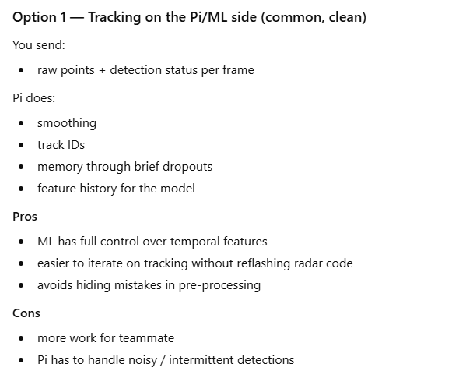
going with this option (unless something changes in the future)
Decided to have the radar be used for detection only as well as not tracking a ‘center’ of the object (keeping all the points detected on the object).

Because I am no longer computing a center from all the points detected on a person, each json that is being sent to the pi will be an array of multiple points that are being detected on a person. Therefore, from one json to the next may or may not have the same number of points being detected on a person. Here is what the json could look like:
"person": {
"num_points": 6,
"confidence": 0.6,
"points": [
{"x":0.42,"y":1.03,"z":0.06,"v":0.31},
{"x":0.45,"y":1.09,"z":0.05,"v":0.29},
{"x":0.39,"y":0.97,"z":0.08,"v":0.34}
]
}

Also the benefit of doing the radar data processing being just detection it’ll preserve the shape, height distribution, and velocity distribution that will make the ML model easier to infer posture, collapse, and motion patterns.

